APPROVED:
Chairman of the Trophy-raid Commission of the Latvian Automobile Federation
01 May 2023
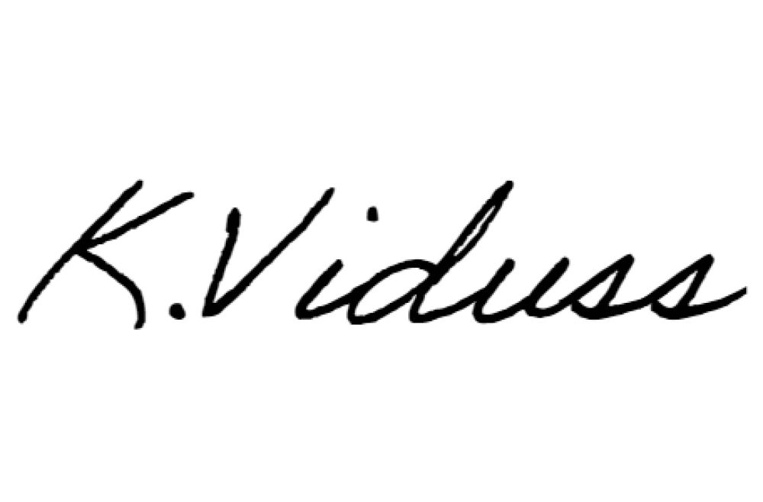
__________________________ K.Vīdušs
APPROVED:
Secretary General of the Latvian Automobile Federation
01 May 2023
____________________________ L.Medne

2023 M. LIETUVOS AUTOMOBILIU BEKELES ČEMPIONATO 2-ASIS ETAPAS

"OFFROADLAND 2023"

Additional Regulations
CONTENT:
- PROGRAMME
- ORGANIZATION
- PARTICIPANTS’ VEHICLE AND EQUIPMENT
- COURSE
- RESPONSIBILITY AND SAFETY
- APPLICATIONS AND DONATIONS
- PROTESTS AND APPEALS
- ADDITIONAL INFORMATION
- PROGRAMME
2023 M. LIETUVOS AUTOMOBILIU BEKELES ČEMPIONATO 2-ASIS ETAPAS "OFFROADLAND 2023" (hereinafter referred to as the Competition) takes place on 26 – 28 May 2023 in Latvia, South Kurzeme Municipality.
Participant registration and technical commission for all sport vehicle categories (TR1, TR2, TR3 and ATV) take place in 1 Ventspils Street, Grobiņa, Grobiņa City, LV-3430, 56.538516, 21.155569
Technical assistance vehicles, trailers together with their towing cars and lorries with trailers must go to the Secretariat of the Competition and the technical commission area, and complete all preparatory procedures — unloading of the sport vehicles, participant registration, vehicle marking, and technical commission.
All crews must access and activate the Black Box 4x4 app (on Android smart devices) during registration. It will be used for speed and distance control, as well as for various special tasks.
Location of the Secretariat of the Competition and the base camp: 1 Ventspils Street, Grobiņa, Grobiņa City, LV-3430, 56.538516, 21.155569
  - Alongside this stage of the Competition, the following takes place:
1.1.1 Trophy – raid tourism cup competition "OFFROADLAND 2023", see Annex 1.
Friday, May 26
At 17:00 to 19:00 Participant registration of sport vehicle categories TR2, TR3 and TR3
At 19:00 – 19:30 technical commission (arrival at the Technical Commission within 30 min after the administrative commission, exact arrival time to be determined during the administrative commission)
19:30 – Opening of the Competition and briefing of the participants
21:00 – Start of the first crew
22:00 – Finish
22:30 – Meeting of the Commissioner’s Jury Saturday, 27 May
At 09:00 – Announcement of the preliminary results and publication of the start list on the official board of information in the Secretariat of the Competition N 57.05664/E 25.92886 and on the websites: www.trofi.lv
At 09:45 – Briefing
At 10:00 – Start of the first crew
At 21:00 – Finish of the last crew
At 22:30 – Meeting of the Commissioner’s Jury
Sunday, May 28
At 09:00 — Announcement of the preliminary results and publication of the start list on the official board of information in the Secretariat of the Competition N 57.05664/E 25.92886 and on the website: www.trofi.lv
At 09:45 – Briefing
At 10:00 – Start of the first crew
At 16:00 – Finish of the last crew
At 16:30 — Announcement of the unofficial results on the official information board at the Secretariat of the Competition
At 17:00 – Announcement of the official results on the official board of information N 57.05664/E 25.92886 and on the website: www.trofi.lv
At 17:30 – Award ceremony
1.2. The Competition takes place in accordance with the Championship 2023 Regulations, LAF National Sports Code and Latvian Trophy Raid Regulations and these additional regulations.
- ORGANIZATION
The Competition is organized by: LAF member – Association “Signāls EM Trophy”, reg. No. 40008295478, address: Madona Municipality, Madona, 21-3 Lazdonas Street, LV-4801; Valdis Madernieks (LV), GSM +371 29385831.
    - Director of the Event – Mārtiņš Kesuss ( +371 26840026)
    - Head of the Commissioner’s Jury – Krišjānis Vīdušs (+371 26664992)
    - Sports Commissioner – Marius Liubartas (LT +370 62084264)
    - Technical Commissioner – Māris Podiņš ( +371 29510940)
    - Head Referee — Kitija Pūpoliņa Podiņa
    - Participant Referee — Martins Dobelis
    - Competition Secretary — Līga Kesus ( +371 26699712) • Medical Support — Inese Lācīte (+371 26586206)
- PARTICIPANTS’ VEHICLE AND EQUIPMENT
  - Any individual who has attained the age of 16 years and has the Trophy-raid participant’s full-season license issued in Latvia, or another member state can participate in the Competition. One-time license can be purchased on the website laflicences.lv (EUR 15) or on the day of the Competition during the registration (EUR 25). The driver must have a valid driving license of the appropriate category.
  - The categories of evaluation in the Competition are as follows:
    - “TR1” — crews driving individually with a TR1 category vehicle, • “TR2” — crews driving individually with a TR2 category vehicle,
    - “TR3” — crews driving individually with the TR3 category vehicles,
    - “TEAM COMPETITION” — two or three crews are united, making a team, irrespective of their categories.
  - Equipment:
    - Food and drinking water supply minima for each crew member (for 10 hours).
    - Clothing suitable for the weather.
    - A digital camera or another smart device with memory card for taking photos.
    - One Android operating system device with an Internet connection and a GPS receiver with installed Black Box 4x4 application, provided with continuous power throughout the Competition and for taking some photographs. • GPS, laptop (recommended).
All crew members must wear an orange vest with reflective elements during the Competition. All crew members must wear a safety helmet!
The use of safety helmets is mandatory during the Competition in all SS. Acceptable types of helmets: motor sport helmets with E22 certification or higher as well as helmets with firm outer cover, with impact reducing filling (foam plastic, foam polystyrene etc.), with inner lining that is an integral part of the helmet and with air holes for ventilation. Helmets for rafting corresponding to standards EN 1078, EN 1077 or ASTM 2040, MTB helmets corresponding to standard Snell B 90, and mountain skiing or ice hockey helmets are also allowed. Construction site, street cycling, as well as all kinds of soft (textile) helmets are not allowed.
  - There are two ways to receive the coordinates of control points:
    - In the documentation or on the website trofi.lv
    - By submitting a USB memory module (flashcard) at the registration for the electronic introduction of coordinates.
Other information mediums (GPS devices, laptops, etc.) are not accepted!
- COURSE
  - The total distance of the Competition course is ~300 km or ~25 hours.
  - The task of the participants is to follow the route set by the Competition Organiser with the help of a legend and a map within a set time, to find and reach all the assigned checkpoints by pulling up to them in a car. The complexity of driving the vehicle next to the control point depends directly on the category of the vehicle.
- RESPONSIBILITY AND SAFETY
  - During the Competition, all vehicles must comply with the Road Traffic Regulations. Participants are responsible for any damage caused to themselves, to other participants or to other persons.
  - The competition application confirms that the participant has become acquainted with the regulations for the year and additional regulations of this Competition and that they fully agree with the regulations and undertake to comply with them.

- APPLICATIONS AND DONATIONS
  - TR1, TR2, TR3 — with LAF or other ASN licenses EUR 180 per car, after 25 May and on the day of the event — EUR 250
  - Donations must be made at the Secretariat on the day of the Event.
  - The Organizer has the right to exempt the participant completely or partially from paying the participation fee.
  - To apply for the Competition, participants must fill in the application form on www.trofi.lv. In case of questions regarding registration, please call +371 26840026.
- PROTESTS AND APPEALS
The submission procedure of protests and appeals is in accordance with the Trophy Raid Regulations 2023, LAF National Sports Code and Trophy–raid competition regulations. The amount of the security deposit for the protest is EUR 100.
- ADDITIONAL INFORMATION
  - The organizer guarantees a parking place for technical assistance vehicles near the base camp of the Competition. Accommodations are available in the tent camp at the base camp and nearby guest houses and hotels in Liepāja.
  - Information for spectators is available on the OFFROADLAND Facebook page www.facebook.com/4x4Liepaja/, at the venue, online and at www.trofi.lv. For any additional information regarding the Competition, please call +371 26840026 (Mārtiņš).
Director of the Competition: 1 May 2022 /Mārtiņš Kesus/

Annex No. 1
LATVIAN TROPHY-RAID TOURISM CUP
3. COMPETITION "OFFROADLAND GROBIŅA TOURISM CUP 2023"
1. PROGRAMME
"OFFROADLAND GROBIŅA TOURISM CUP 2023" (hereinafter referred to as the Competition) takes place on 27 May 2023 in Latvia,
South Kurzeme Municipality. Location of the Secretariat of the Competition and the base camp: 1 Ventspils Street, Grobiņa, Grobiņa City, LV-3430, 56.538516, 21.155569

Saturday, May 27
At 08:00 to 10:15 — Registration of the participants
At 08:00 to 10:30 — Technical commission
At 10:45 — Briefing
At 11:00 — Start of the first crew
At 21:00 — Finish of the last crew
At 21:30 — Announcement of the unofficial results on the official information board at the Secretariat of the Competition. At 22:00 - Publication of the official results on the official information board in the secretariat of the Competition and on the website www.trofi.lv. At 22:30 — Award ceremony
The competition is held in accordance with the "TOURISM CUP 2023" regulations.
- ORGANIZATION
The Competition is organized by: LAF member — Association “Signāls EM Trophy”, reg. No. 40008295478, address: Madona Municipality, Madona, 21-3 Lazdonas Street, LV-4801, Valdis Madernieks (LV), GSM +371 29385831.
    - Director of the Event — Mārtiņš Kesuss ( +371 26840026)
    - Sports Commissioner — Krišjānis Vīdušs (+371 26664992)
    - Technical Commissioner — Māris Podiņš ( +371 29510940)
    - Head Referee — Kitija Pūpoliņa Podiņa
    - Participant Referee — Martins Dobelis
    - Competition Secretary — Līga Kesus
    - Medical assistance — Inese Lācīte (+371 26586206)
- PARTICIPANTS’ VEHICLE AND EQUIPMENT
  - Any individual can participate in the Competition. The driver must have a valid driving license of the appropriate category.
  - The starting vehicle must have a valid annual Technical Inspection sticker and a valid OCTA (MTPL) insurance policy.
  - Participants of the AUTO, ATV and SBS categories participate individually (all forms of self-towing equipment are allowed).
  - All crews must access and activate the Black Box 4x4 app (on Android smart devices) during registration. It will be used for speed and distance control, as well as for various special tasks.
  - Equipment:
    - Food and drinking water supply minima for each crew member (for 12 hours).
    - Clothing suitable for the weather.
    - A digital camera or another smart device with memory card for taking photos.
    - One Android operating system device with an Internet connection and a GPS receiver with installed Black Box 4x4 application, provided with continuous power throughout the Competition and for taking some photographs. • GPS, laptop (recommended).
    - Torch, towing rope, and a map of the South Kurzeme Municipality.

- COURSE
  - The total distance of the Competition course is ~250 km or ~10 hours.
  - The task of the participants is to complete the route set by the Competition Organiser in the defined period by using a legend, directions, and a map, and to find and reach all the assigned checkpoints by pulling up to them in a car if required and to take a picture. To complete all tasks given by the organizers.
- RESPONSIBILITY AND SAFETY
  - During the Competition, all vehicles must comply with the Road Traffic Regulations. Participants are responsible for themselves, and any damage caused to other participants or other persons.
  - The competition application confirms that the participant has become acquainted with "OFFROADLAND GROBIŅA 2023" Tourism Cup regulations, fully agrees to them and undertakes to comply with them.
  - Organizers have the right to establish any restrictions, and the participants are obliged to comply with them.
- APPLICATIONS AND DONATIONS
  - For applications before 25 May — EUR 150 per car/side by side/quadricycle pair, for applications after 25 May — EUR 200.
  - To apply for the Competition participants must fill in the application form on www.trofi.lv. In case of questions regarding registration, please call +371 26840026.
Donations must be made at the Secretariat on the day of the Event.
The Organizer has the right to exempt the participant completely or partially from paying the participation fee.
- ADDITIONAL INFORMATION
  - The organizer guarantees a parking place for technical assistance vehicles near the base camp of the Competition. Accommodations are available in the tent camp at the base camp and nearby guest houses and hotels in Liepāja. 7.2 Information for spectators is available on the OFFROADLAND Facebook page www.facebook.com/4x4Liepaja/, at the venue, online and at www.trofi.lv. For any additional information regarding the Competition, please call +371 26840026 (Mārtiņš).
Director of the Competition: 1 May 2022 /Mārtiņš Kesus/

Annex No. 3
Side by Side
REGULATIONS
1. PROGRAMME
"OFFROADLAND GROBIŅA SIDE BY SIDE TOURISM CUP 2023" (hereinafter referred to as the Competition) takes place on 27 May 2023 in the South Kurzeme Municipality, Latvia. Location of the Secretariat of the Competition and the base camp: 1 Ventspils Street, Grobiņa, Grobiņa City, LV-3430, 56.538516, 21.155569
Saturday, May 27
At 08:00 to 10:15 — Registration of the participants
At 08:00 to 10:30 — Technical commission
At 10:45 — Briefing
At 11:00 — Start of the first crew
At 21:00 — Finish of the last crew
At 21:30 — Announcement of the unofficial results on the official information board at the Secretariat of the Competition. At 22:00 — Publication of the official results on the official information board in the Secretariat of the Competition and on the website www.trofi.lv. At 22:30 – Award ceremony
The competition is held in accordance with the "TOURISM CUP 2023" regulations.
- ORGANIZATION
The Competition is organized by: LAF member – Association “Signāls EM Trophy”, reg. No. 40008295478, address: Madona Municipality, Madona, 21-3 Lazdonas Street, LV-4801, Valdis Madernieks (LV), GSM +371 29385831.
    - Director of the Event — Mārtiņš Kesuss ( +371 26840026)
    - Sports Commissioner — Krišjānis Vīdušs (+371 26664992)
    - Technical Commissioner — Māris Podiņš ( +371 29510940)
    - Head Referee — Kitija Pūpoliņa Podiņa
    - Participant Referee — Martins Dobelis
    - Competition Secretary — Līga Kesus
    - Medical assistance — Inese Lācīte (+371 26586206)
- PARTICIPANTS’ VEHICLE AND EQUIPMENT
  - Any individual can participate in the Competition. The driver must have a valid driving license of the appropriate category.
  - The starting vehicle must have a valid annual Technical Inspection sticker and a valid OCTA (MTPL) insurance policy.
  - Participants of the AUTO category participate individually (all forms of self-towing equipment are allowed). 3.4 All crews must access and activate the Black Box 4x4 app (on Android smart devices) during registration. It will be used for speed and distance control, as well as for various special tasks.
3.5 Equipment:
      - Food and drinking water supply minima for each crew member (for 12 hours).
      - Clothing suitable for the weather.
      - A digital camera or another smart device with memory card for taking photos.
      - One Android operating system device with an Internet connection and a GPS receiver with installed Black Box 4x4 application, provided with continuous power throughout the Competition and for taking some photographs.
      - GPS, laptop (recommended).
      - Torch, towing rope, and a map of Madona municipality.
- COURSE
  - The total distance of the Competition course is ~250 km or ~10 hours.
  - The task of the participants is to complete the route made by the Competition Organiser in the defined period by using a legend, with time control. The Competition takes place on individual off-road speed stages with closed traffic. To complete all tasks given by the organizers.
- RESPONSIBILITY AND SAFETY
  - During the Competition, all vehicles must comply with the Road Traffic Regulations. Participants are responsible for themselves, and any damage caused to other participants or other persons.
  - The competition application confirms that the participant has become acquainted with "OFFROADLAND GROBIŅA 2023" Tourism Cup regulations, fully agrees to them and undertakes to comply with them.
  - Organizers have the right to establish any restrictions, and the participants are obliged to comply with them.
- APPLICATIONS AND DONATIONS
  - For applications before 25 May — EUR 150 per car/side by side, for applications after 25 May — EUR 280.
  - To apply for the Competition participants must fill in the application form on www.trofi.lv. In case of questions regarding registration, please call +371 26840026.
Donations must be made at the Secretariat on the day of the Event.
The Organizer has the right to exempt the participant completely or partially from paying the participation fee.
- ADDITIONAL INFORMATION
  - The organizer guarantees a parking place for technical assistance vehicles near the base camp of the Competition. Accommodations are available in the tent camp at the base camp and nearby guest houses and hotels in Liepāja.
  - Information for spectators is available on the OFFROADLAND Facebook page www.facebook.com/4x4Liepaja/, at the venue, online and at www.trofi.lv. For any additional information regarding the Competition, please call +371 26840026 (Mārtiņš).
Director of the Competition: 1 May 2022 /Mārtiņš Kesus/

